Mission Statement
Hanover College is dedicated to being a challenging and supportive community engaging in transformative scholarly inquiry that establishes a foundation for lifelong service and learning.

Professor: Office Phone:
Office: Cell Phone:
Office Hours: Email:
Class Schedule:
Prerequisite:
Catalog Description:

Field Experiences-

Required Reading:

Course Context:

Course Goals
The teacher candidate will be committed, competent, culturally responsive, and critically reflective.

COMMITTED
Disposition: The candidate will be aware of his/her own values and beliefs about teaching and learning and will be committed to self-reflection, assessment, and personal learning as an ongoing process.
(INTASC Principle 1)

Disposition: The candidate will be committed to professional reading, reflection, and discussion about subject matter knowledge and children’s learning. (INTASC Principle 1 and 9)

Performance: The candidate will read a substantial number of children’s and young adult books.

COMPETENT
Knowledge: The candidate will discuss and write about content and practices relevant to teaching and learning. (INTASC Principle 1 and 4)

Knowledge: The candidate will understand and articulate the educational foundations of current instruction and practice in elementary schools. (INTASC Principles 1, 2, 8)

Performance: The candidate will synthesize and apply pedagogy to the planning and implementation of lessons and assessment of student learning.
(all INTASC Principles)

Performance: The candidate will use Standard English, grammar, and spelling in all written and verbal communication. (INTASC Principle 1)

CULTURALLY RESPONSIVE
Disposition: The candidate will strive to recognize and appreciate the value that diversity brings to the classroom and to our culture. (INTASC Principle 3)

Disposition: The candidate will recognize that all children can learn at high levels and will persist in helping all children achieve success. (INTASC Principle 3)

Performance: The candidate will address student diversity and individual differences through selection of appropriate children’s and young adult literature. (INTASC Principle 3)

CRITICALLY REFLECTIVE
Disposition: The candidate will reflect upon his/her classroom involvement. (INTASC Principle 9)

Instructional Strategies
Mini lecture Use of Technology
Discussion/Questioning Discovery
Practice Project Work
Viewing/Listening/Answering Educational Research
Problem Solving Cooperative Learning

The course addresses The National Educational Technology Standards for Teachers (NETS-T) and The National Educational Technology Standards for Students (NETS-S):
- http://www.iste.org/standards/nets-for-teachers/nets-for-teachers-2008.aspx
- http://www.iste.org/standards/nets-for-students.aspx

Assessment of Learning and Competence:

Grading Scale and Policy on Plagiarism: See attached course policies and guidelines.

Attendance Policy:
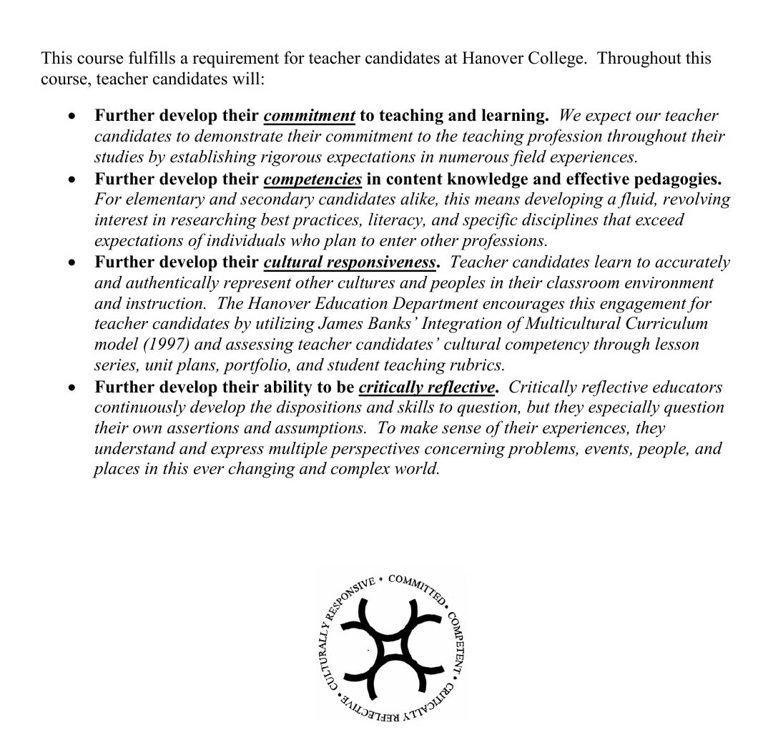
Tentative Course Outline and Assignments
The Course Outline for each of our class meetings is detailed in the pages that follow. We will attempt to keep to this schedule as it is outlined below. Like any schedule, though, change is always possible. It is your responsibility to be aware of any changes we might make to the schedule.

