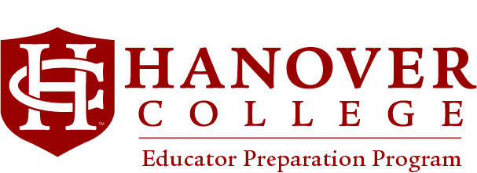

Advising for Special Education (Teaching Diverse Learners Program)

Indiana P-12 Exceptional Needs: Mild Intervention Certification

Teacher candidates must also complete either an Elementary Education (K-6) Certification or Secondary Education (P-12/5-12) Certification Program. Mild Interventions is not a “stand-alone” program, however, it does require an additional CORE licensing exam.
Non-degree seeking students (licensed Indiana educators) do not need EDU 458 (Integrated Student Teaching)

Courses | Credit | Semester Taken
EDU 252 Professional Collaboration | 1 unit
EDU 253 Instruction and Assessment | 1 unit
EDU 254 Special Education Law & Policy | 1 unit
EDU 255 Classroom Management & PBIS | 1 unit
EDU 256 Learning Environments & Transition | 1 unit
EDU 458 Integrated Student Teaching  Required for both Elementary and Secondary Dual Certification* Offered Fall and Winter Terms  NOT REQUIRED FOR LICENSED TEACHERS. | 4 units

These courses may be taken in any order and do not have any prerequisites for enrollment.

