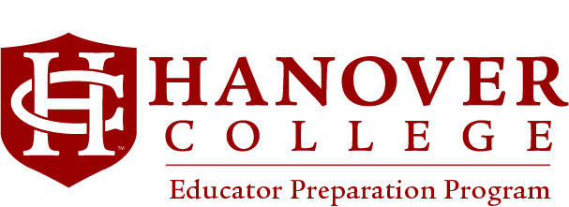

Political Science Major with Secondary Education Dual Major
Social Studies: Civics and Government
(Indiana Government Grades 5-12)
revised 5.2020
Core Curriculum Requirement (CCRs) | Units Req. | Course
FY Experience/FY Seminar | 0.5
LA-Literary and Artistic Perspectives #1 | 1
LA-Literary and Artistic Perspectives #2 | 1
HS-Historical and Social Perspectives #1 | 1
HS-Historical and Social Perspectives #2 | 1
PP- Philosophical Perspectives | 1
RP-Religious Perspectives | 1
SL- Algorithmic, Mathematical, Scientific | 1
SM- Algorithmic, Mathematical, Scientific | 1
SM- Algorithmic, Mathematical, Scientific | 1
WL-World Languages and Cultures #1 | 1
WL-World Languages and Cultures #2 (sequential) | 1
AF-Health and Fitness (Applied) #1 | 0.25
AF-Health and Fitness (Applied) #2 | 0.25
Total CCR units | 12 units
Areas of Competency and Engagement (ACES) |  | Course
W1-Writing | 1
W2-Writing | 1
S-Speaking | 1
CP-Cultural Perspectives | 1
QL- Quantitative Reasoning | 1
 | 5 units

Requirements for Licensing Certification with Dual Secondary Education Major | Units Req. | Course Semester
EDU 221 Education and the American Culture | 1
EDU 231 Education Law and Ethics | 1
EDU 252 Professional Collaboration | 1
EDU 255 Classroom Management & PBIS | 1
EDU 226 Integrating Technologies in Instruction | 1
EDU 312 Urban Teaching (EDU Admission Required) | 1
EDU 314 Secondary Methods: Teaching Middle School (EDU Admission Req) | 1
EDU 315 Secondary Methods: Teaching High School (EDU Admission Req’d) | 1
EDU 338 Secondary Social Studies Methods (EDU Admission Required) | 1
EDU 455 Student Teaching in Secondary Schools (EDU Admission Required) | 4
EDU 461 Senior Seminar | 1
EDU 499 Comprehensive Examination | -
Cognate Courses (Required)
PSY 111 Basic Principles of Psychology | 1
PSY 244 Childhood and Adolescence | 1
Total EDU units | 16

Political Science Major Requirements | Units Req. | Course/Semester
PLS 161 | 1
PLS 213 | 1
PLS 215 | 1
PLS 222 *ADDITIONAL COURSE REQUIRED | 1
PLS 235 | 1
PLS 239 | 1
PLS 325 | 1
PLS 326 | 1
PLS 331 | 1
PLS 461 Culminating Experience | 1
PLS 499 Comprehensive Exam | -
COGNATE COURSE
MATH 217 | 1
Total | 11

*Optional Dual Certification Special Education Available
See Teaching Diverse Learners Program Advising Sheet
Please refer to the academic catalog for complete details on graduation requirements.
While the academic advisors and other personnel are available for assistance, the primary responsibility for taking appropriate and required courses to meet graduation requirements rests with the student.

Compliance with REPA content and pedagogy established by the Indiana Department of Education, National Council of Social Studies (NCSS) and is required by the Educator Preparation Program’s policies, curricula, and course content regardless of the student’s admission date in the program.
REVIEWED WITH THE POLITICAL SCIENCE DEPARTMENT _____________DATE______________

NOTES:

