SFS Subscription Payments
When logged in as a student, you will see your subscription status and a link to ‘SFS Subscription’ on your home page:
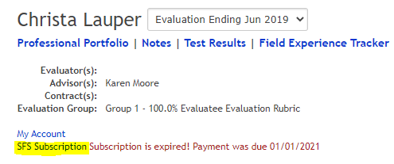
The link will take you to your Subscription payment history and give you the option to make a payment.
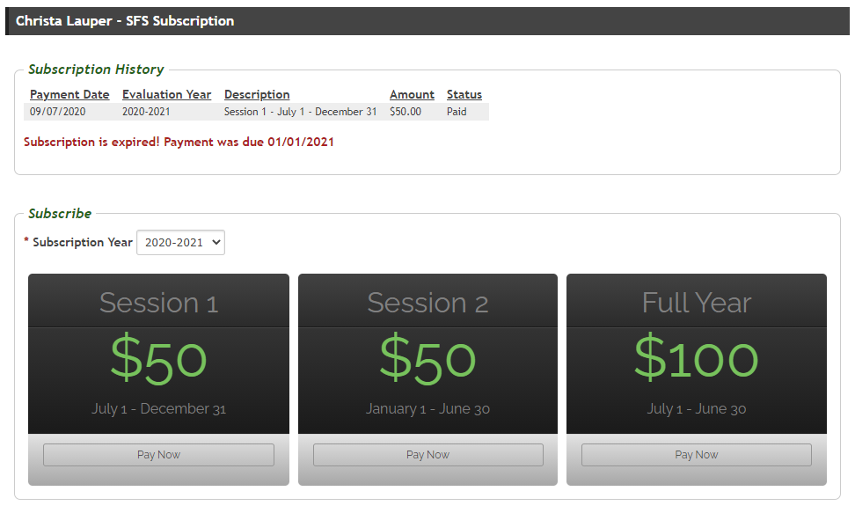
To make a payment, simply select the subscription year and a payment option.

