Hanover College
Office of Education Student Services

Praxis CORE exam prep tools from the Hanover College Duggan Library (with screen shots).
- Navigate to https://library.hanover.edu/
- Click on blue box “Databases A-Z”
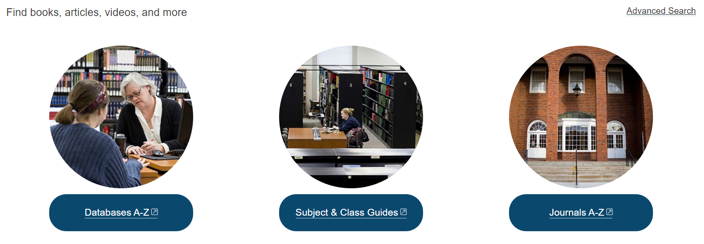
- Click on the letter T and you will see “Testing and Education Resource Center” underneath.
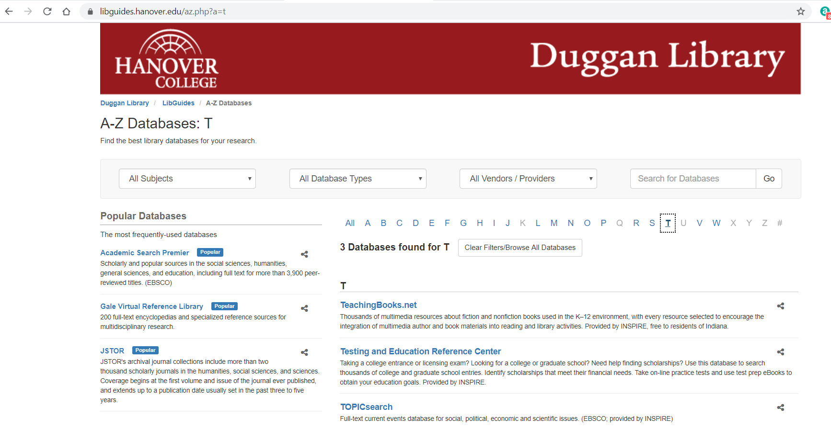
- On the “What type of student are you?” choose CAREER and click the gold START button.
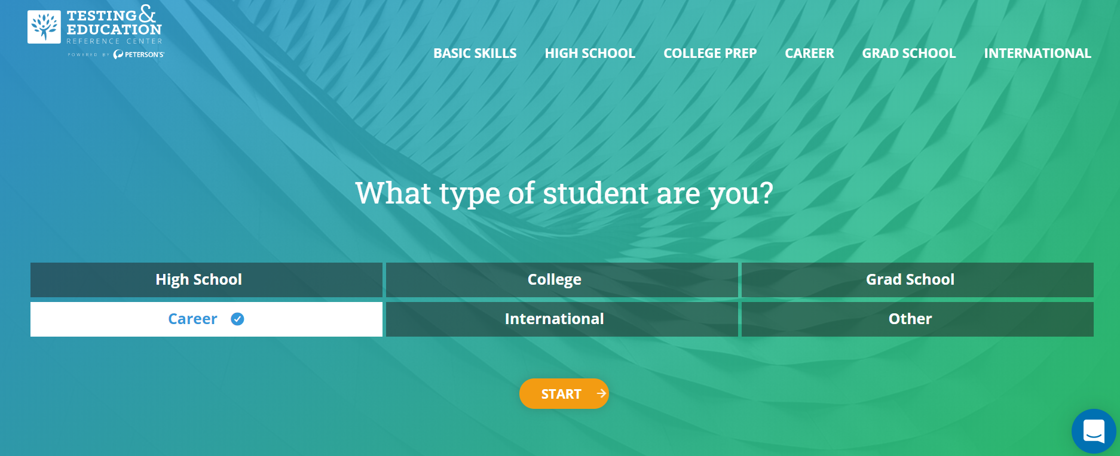
- From the next screen you can choose “Practice for a career related exam”and click the gold START button.
NOTE: You can also come back and choose “Get general basic skills help” which is the kind of tests the Praxis Core has – Reading, Mathematics, Writing. *Writing requirement will begin in 2021.
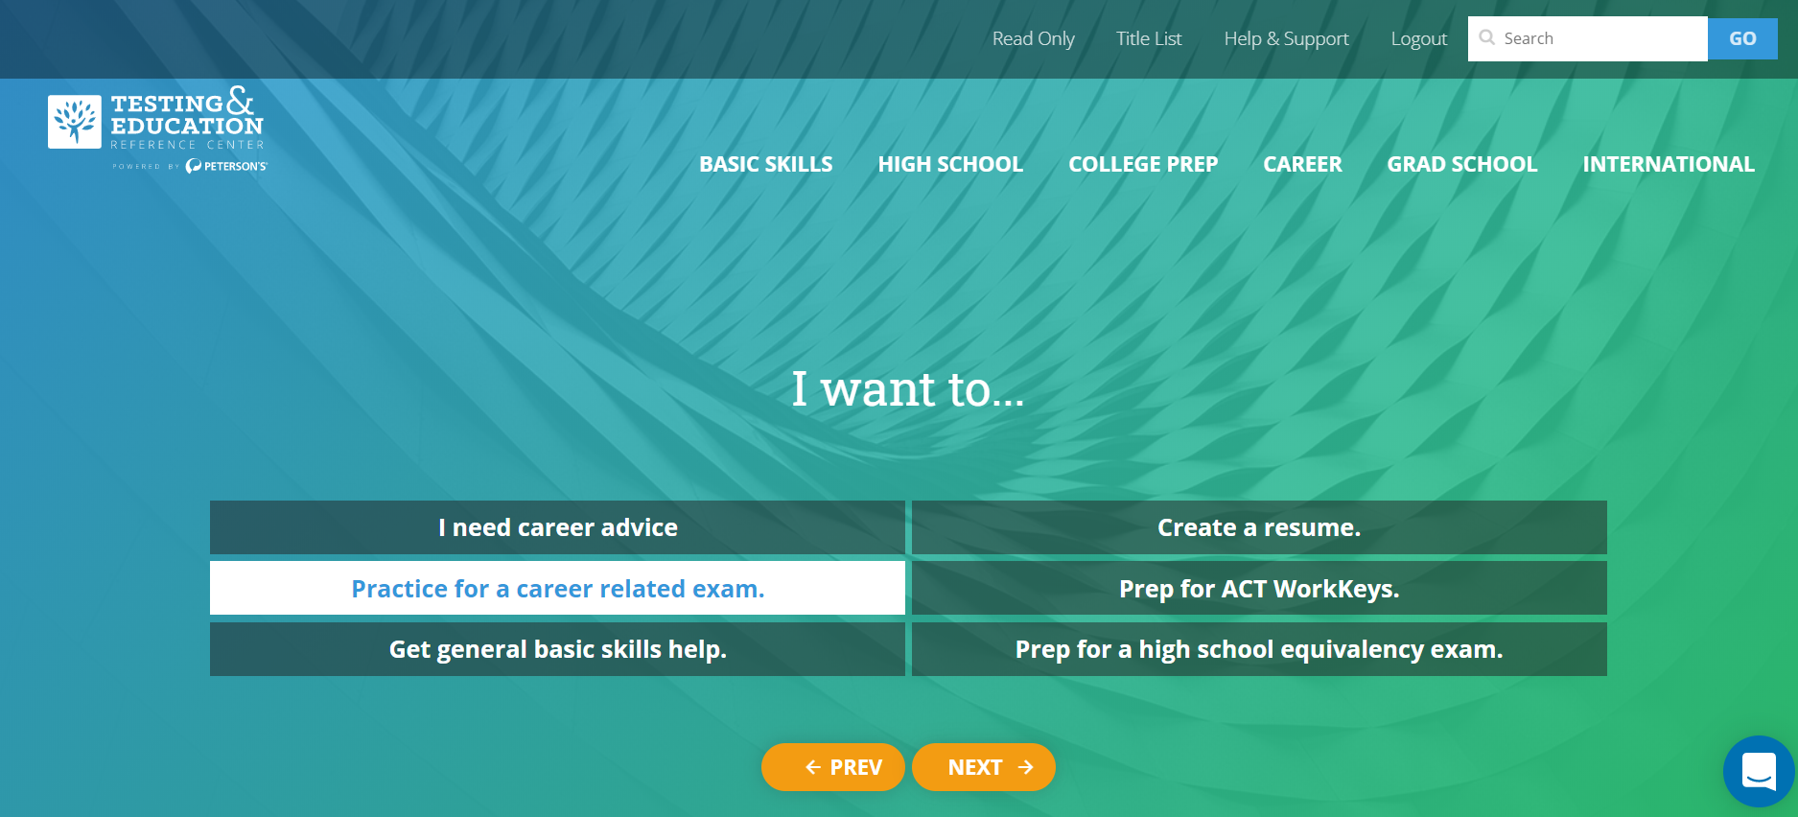
Scroll to the bottom of the list and click on TEACHER PREP
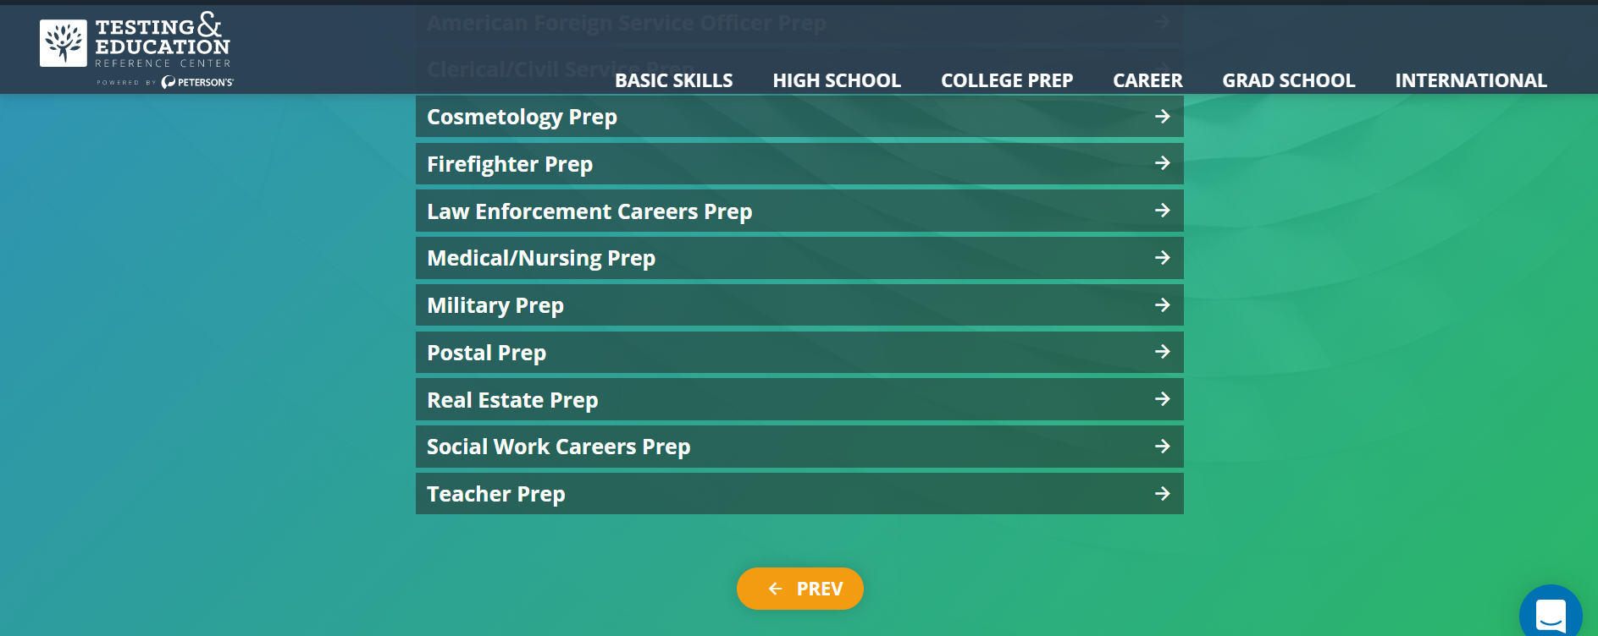
- On this page you will find Online Practice Tests – choose Practice Tests for the Praxis CORE exams
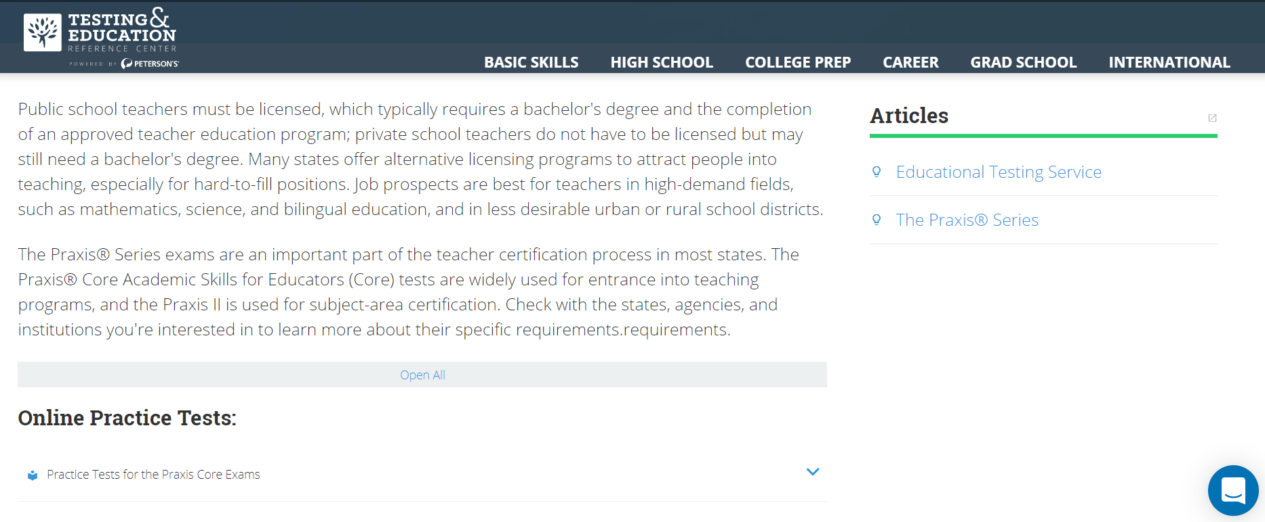
- On the next page, click on the gold START NOW button.
NOTE: Disregard Online Books or anything that says “Praxis II”
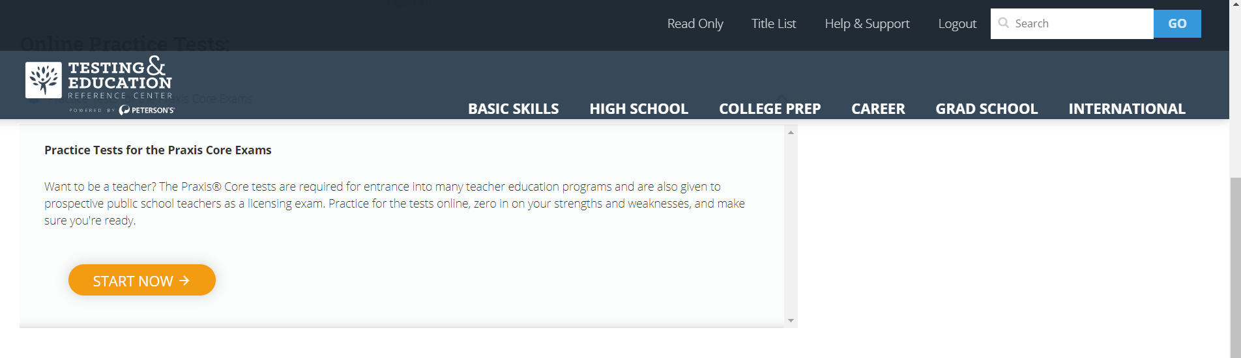
- The first time you will need to sign up for an account – be sure to use your Hanover College email when requested. Note your log in name and password!

- Peterson’s Practice Tests will ask for your test or goal date to set up your study plan. Then click the blue box to CONTINUE -
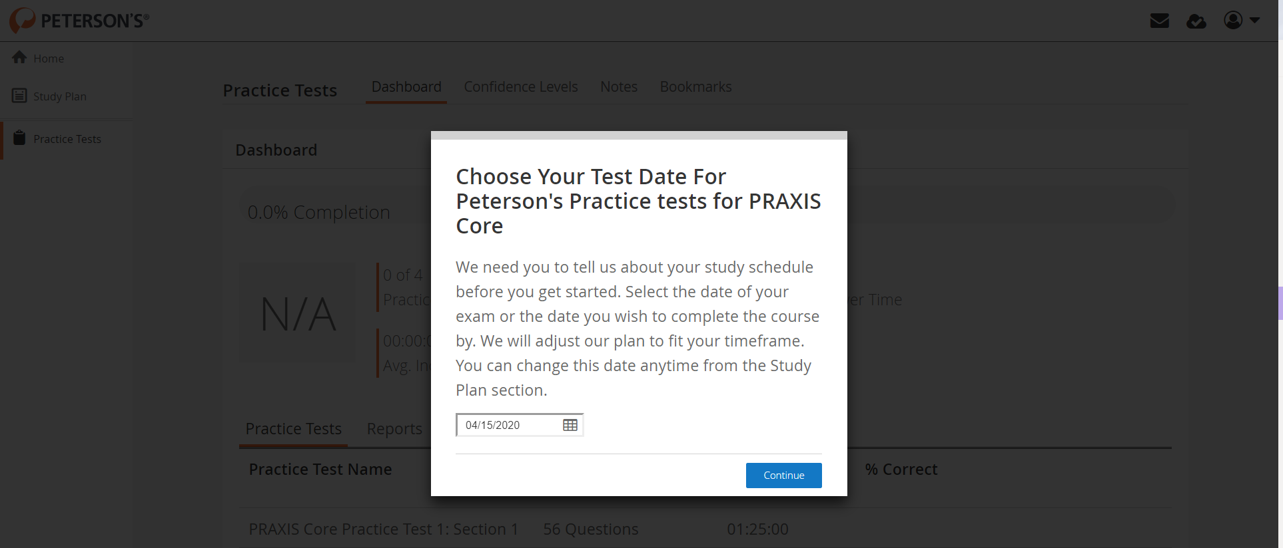
- You will be taken to your Peterson’s Dashboard: at far right is Home/Study Plan/Practice Tests. You will get Reports on your progress as you work through your study plan and practice tests. This is a great tool to know when you are ready to succeed at taking the Praxis Core Exam.
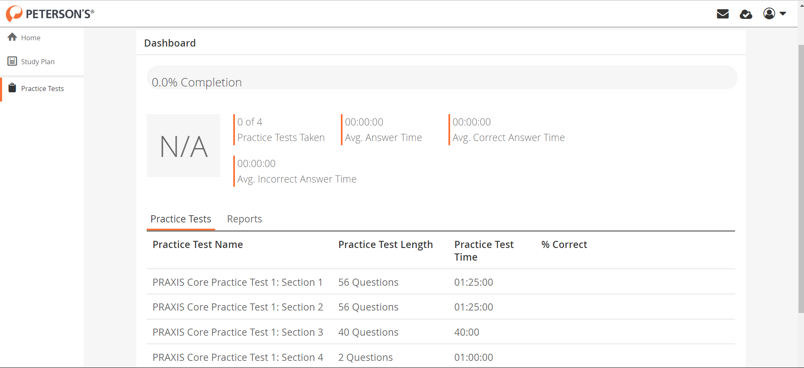
- With good preparation you will do well – without preparation – probably not!!!

